
Appropriation Act (No. 2) 1999-2000
Act No. 47 of 1999 as amended
This compilation was prepared on 6 January 2011
taking into account amendments up to Financial Management and Accountability Act 1997 Determination 2010/37 — Section 32 (Transfer of Functions from AGD to DORA)
The text of any of those amendments not in force
on that date is appended in the Notes section
The operation of amendments that have been incorporated may be
affected by application provisions that are set out in the Notes section
Prepared by the Office of Legislative Drafting and Publishing,
Attorney-General’s Department, Canberra

Contents
Part 1—Preliminary 1
1 Short title [see Note 1] 1
2 Commencement [see Note 1] 1
3 Definitions 1
4 Notional payments, receipts etc. 2
Part 2—Basic appropriations 4
5 Summary of basic appropriations 4
6 State payment items—basic appropriation 4
7 Administered items—basic appropriation 4
8 Administered capital items—basic appropriation 5
9 Departmental capital items—basic appropriation 5
Part 3—Additions to basic appropriations 6
10 Advance to the Finance Minister—unforeseen expenses etc. 6
Part 4—Miscellaneous 7
11 Crediting amounts to Special Accounts 7
12 Conditions etc. applying to State payment items 7
13 Appropriation of the Consolidated Revenue Fund 8
Schedule 1—Payments to or for the States 9
Schedule 2—Services for which money is appropriated 12
Notes 65

An Act to appropriate money out of the Consolidated Revenue Fund for certain expenditure in respect of the year ending on 30 June 2000, and for related purposes

Part 1—Preliminary

1 Short title [see Note 1]
This Act may be cited as the Appropriation Act (No. 2) 1999-2000.

2 Commencement [see Note 1]
This Act commences on the day on which it receives the Royal Assent.

3 Definitions
In this Act, unless the contrary intention appears:
administered capital item means an amount set out in Schedule 2 in relation to an entity opposite the heading “Administered Capital”.
administered item means an amount set out in Schedule 2 opposite an outcome of an entity under the heading “Other Administered Expenses”.
Agency has the same meaning as in the Financial Management and Accountability Act 1997.
Appropriation Bill means the Bill for this Act.
Commonwealth authority has the same meaning as in the Commonwealth Authorities and Companies Act 1997.
Commonwealth company has the same meaning as in the Commonwealth Authorities and Companies Act 1997.
current year means the financial year ending on 30 June 2000.
departmental capital item means an amount set out in Schedule 2 in relation to an entity:
(a) opposite the heading “Equity Injections”; or
(b) opposite the heading “Loans”; or
(c) opposite the heading “Carryover from previous years”.
departmental expenses includes payments for the acquisition of assets.
entity means any of the following:
(a) an Agency;
(b) a Commonwealth authority;
(c) a Commonwealth company.
Finance Minister means the Minister administering this Act.
item means any of the following:
(a) a State payment item;
(b) an administered item;
(c) an administered capital item;
(d) a departmental capital item.
Portfolio Budget Statements means the Portfolio Budget Statements that were tabled in the Senate or the House of Representatives in relation to the Appropriation Bill and the Bill for the Appropriation Act (No. 1) 1999-2000.
Special Account has the same meaning as in the Financial Management and Accountability Act 1997.
State includes the Australian Capital Territory and the Northern Territory.
State payment item means an amount set out in Schedule 2 opposite an outcome of an entity under the heading “Specific Payments to the States and Territories”.

4 Notional payments, receipts etc.
For the purposes of this Act, notional transactions between Agencies are to be treated as if they were real transactions.
Note: This section applies, for example, to a “payment” between Agencies that are both part of the Commonwealth. One of the effects of this section is that the payment will be debited from an appropriation for the paying Agency, even though no payment is actually made from the Consolidated Revenue Fund.

Part 2—Basic appropriations

5 Summary of basic appropriations
The total of the items specified in Schedule 2 is $5,735,166,000.
Note: Items in Schedule 2 can be increased under Part 3 of this Act and under section 11 of the Appropriation Act (No. 1) 1999-2000.

6 State payment items—basic appropriation
(1) For a State payment item for an outcome of an entity, the Finance Minister may issue out of the Consolidated Revenue Fund amounts that do not exceed, in total, the lesser of:
(a) the amount specified in the item; and
(b) the amount determined by the Finance Minister to be the expenses incurred by the entity in the current year in relation to the item.
(2) An amount issued out of the Consolidated Revenue Fund for a State payment item for an outcome may only be applied for the purpose of making payments to or for the States for the purpose of contributing to achieving that outcome.

7 Administered items—basic appropriation
(1) For an administered item for an outcome of an entity, the Finance Minister may issue out of the Consolidated Revenue Fund amounts that do not exceed, in total, the lesser of:
(a) the amount specified in the item; and
(b) the amount determined by the Finance Minister to be the administered expenses incurred by the entity in the current year in relation to the item.
(2) An amount issued out of the Consolidated Revenue Fund for an administered item for an outcome may only be applied for expenditure for the purpose of carrying out activities for the purpose of contributing to achieving that outcome.
Note: An administered item may be used to acquire assets. However, the acquisition of new assets will usually be funded from an administered capital item.
(3) If the Portfolio Budget Statements indicate that activities of a particular kind were intended to be treated as activities in respect of a particular outcome, then expenditure for the purpose of carrying out those activities is taken to be expenditure for the purpose of contributing to achieving the outcome.

8 Administered capital items—basic appropriation
(1) For an administered capital item for an entity, the Finance Minister may issue out of the Consolidated Revenue Fund amounts that do not exceed, in total, the amount specified in the item.
(2) An amount issued out of the Consolidated Revenue Fund for an administered capital item for an entity may only be applied for expenditure for the purpose of carrying out activities for the purpose of contributing to achieving any outcome that is specified in relation to the entity:
(a) in Schedule 2 to this Act; or
(b) in the Schedule to the Appropriation Act (No. 1) 1999-2000.

9 Departmental capital items—basic appropriation
(1) For a departmental capital item for an entity, the Finance Minister may issue out of the Consolidated Revenue Fund amounts that do not exceed, in total, the amount specified in the item.
Note: Generally, the Finance Minister is permitted, but not obliged, to issue the amounts out of the Consolidated Revenue Fund. However, subsection (3) imposes an obligation on the Finance Minister to issue the amounts in certain circumstances.
(2) An amount issued out of the Consolidated Revenue Fund for a departmental capital item may only be applied for the departmental expenses of the entity.
(3) If:
(a) an Act provides that an entity must be paid amounts that are appropriated by the Parliament for the purposes of the entity; and
(b) Schedule 2 contains a departmental capital item for that entity;
then the Finance Minister, under subsection (1), must issue out of the Consolidated Revenue Fund the full amount specified in the item.

Part 3—Additions to basic appropriations

10 Advance to the Finance Minister—unforeseen expenses etc.
(1) This section applies if:
(a) an entity has incurred, or is likely to incur, an expense (the extra expense) during the current year in relation to an item (the insufficient item) for the entity; and
(b) the Finance Minister is satisfied that:
(i) the expense was unforeseen until after the last day on which it was practicable to provide for the extra expense in the Appropriation Bill before that Bill was introduced into the House of Representatives; or
(ii) because of an erroneous omission or understatement, provision for the extra expense was not made in the Appropriation Bill; and
(c) the Finance Minister considers that there is an urgent need to increase the insufficient item to make provision for the extra expense.
(2) The amount of the insufficient item is taken to be increased by such amount (if any) as the Finance Minister determines, up to the amount of the extra expense.
(3) The total of the amounts determined under this section cannot be more than $215 million.
(4) The Finance Minister must give the Parliament details of amounts determined under this section.

Part 4—Miscellaneous

11 Crediting amounts to Special Accounts
If any of the purposes of a Special Account is a purpose that is covered by an item (whether or not the item expressly refers to the Special Account), then amounts may be debited against the appropriation for that item and credited to that Special Account.

12 Conditions etc. applying to State payment items
(1) This section applies to any payment made out of money appropriated by a State payment item for an outcome identified in column 2 of the table in Schedule 1.
(2) The payment:
(a) must be made on the applicable terms and conditions (if any) for that outcome; and
(b) must be made in the amounts, and at the times, that are determined in writing by the Minister specified in column 4 of the table.
(3) This section does not, by implication, limit the power of the Commonwealth to:
(a) apply terms and conditions to non-State payments; or
(b) determine the amounts and times of non-State payments.
(4) In this section:
applicable terms and conditions, in relation to an outcome identified in the table in Schedule 1, means terms and conditions from time to time determined in writing by the Minister specified in column 3 of the table, as being the terms and conditions that apply to payments that are made to or for a State in relation to that outcome out of money appropriated by an annual Appropriation Act.
non-State payment means a payment made out of money that is appropriated by the Parliament (either under this Act or another Act), other than a payment out of money appropriated by a State payment item.

13 Appropriation of the Consolidated Revenue Fund
The Consolidated Revenue Fund is appropriated as necessary for the purposes of this Act.

Schedule 1—Payments to or for the States
Note: See Section 12
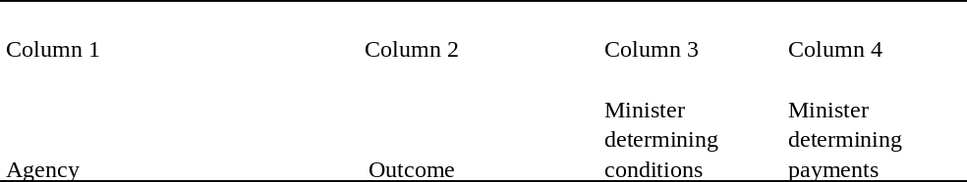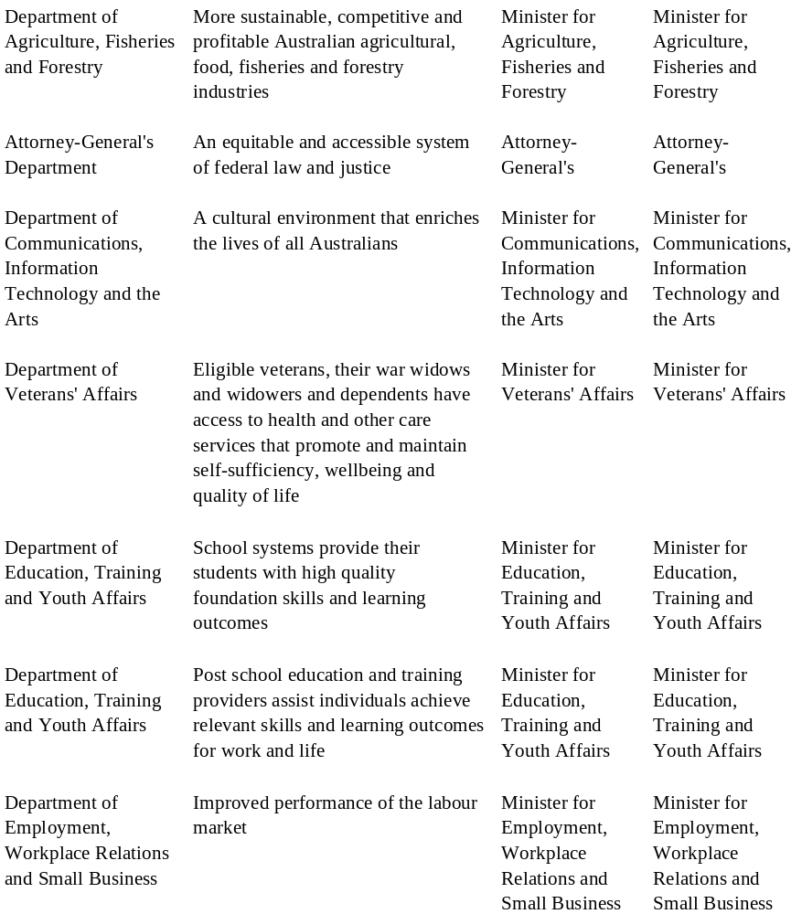
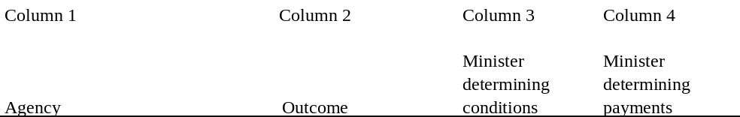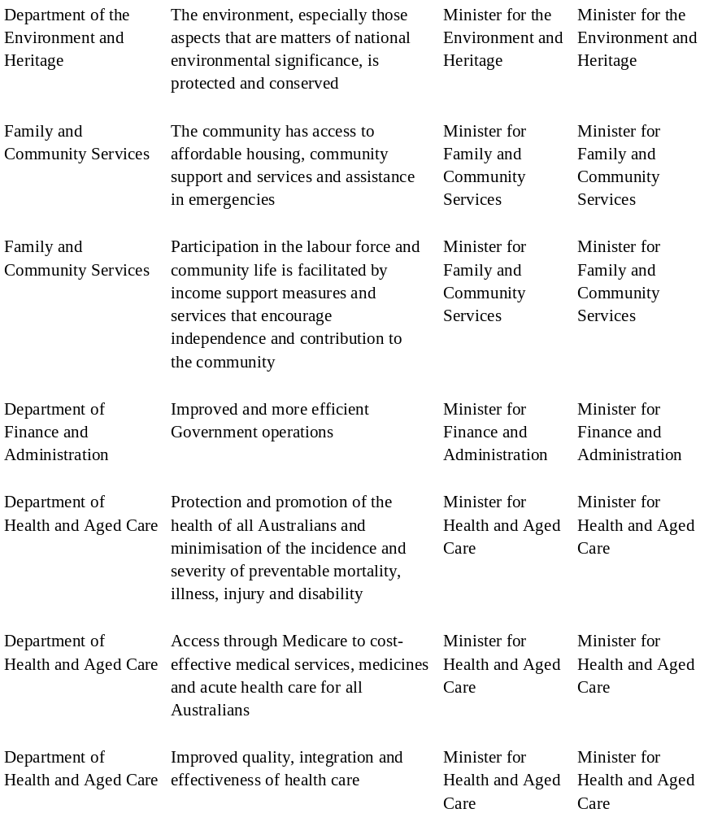
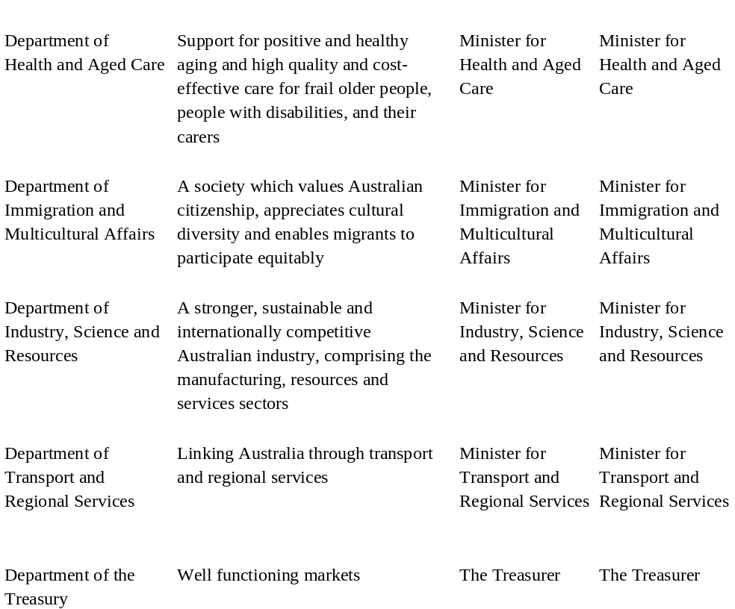
__________________

Schedule 2—Services for which money is appropriated
Note: See Sections 5 and 13
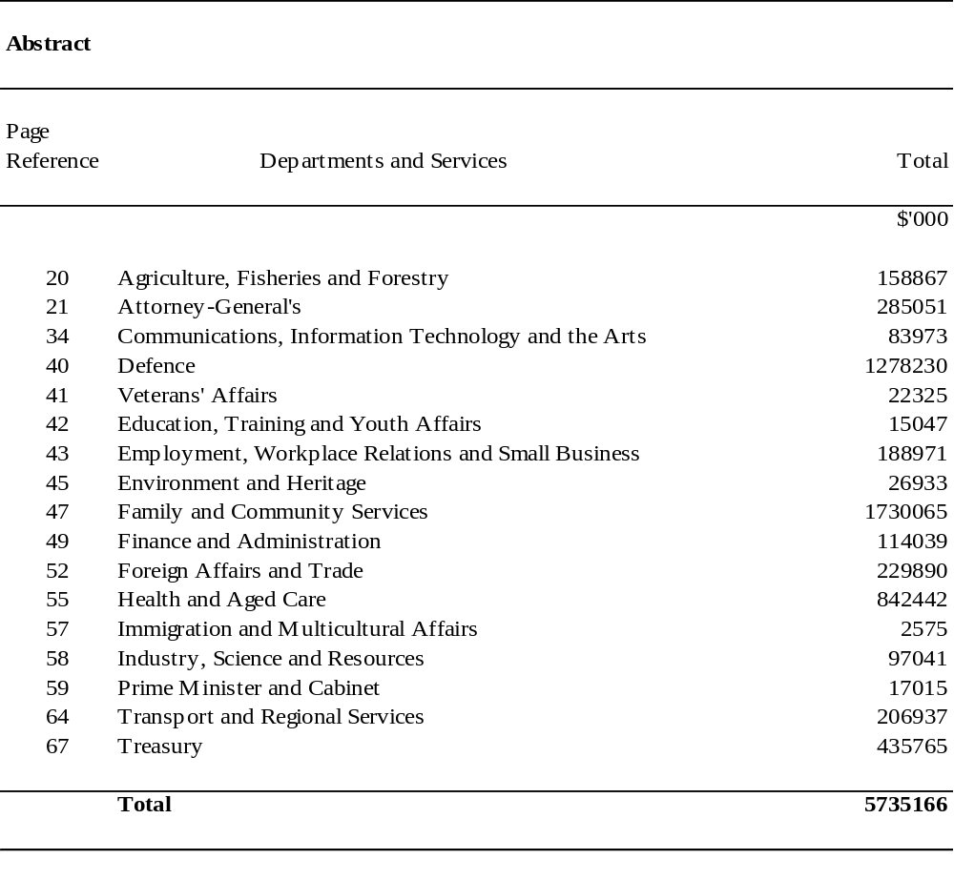

DEPARTMENTS AND SERVICES
Appropriation (light figures) – 1999-2000
Estimated Expenses (italic figures) – 1998-1999
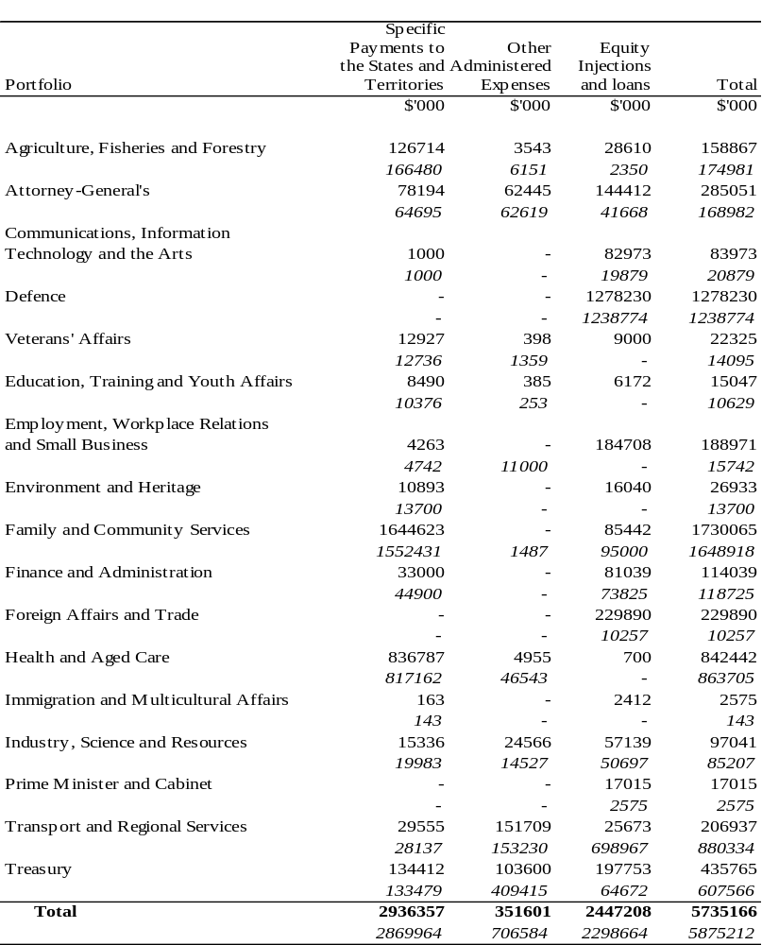
AGRICULTURE, FISHERIES AND FORESTRY PORTFOLIO
Appropriation (light figures) – 1999-2000
Estimated Expenses (italic figures) – 1998-1999
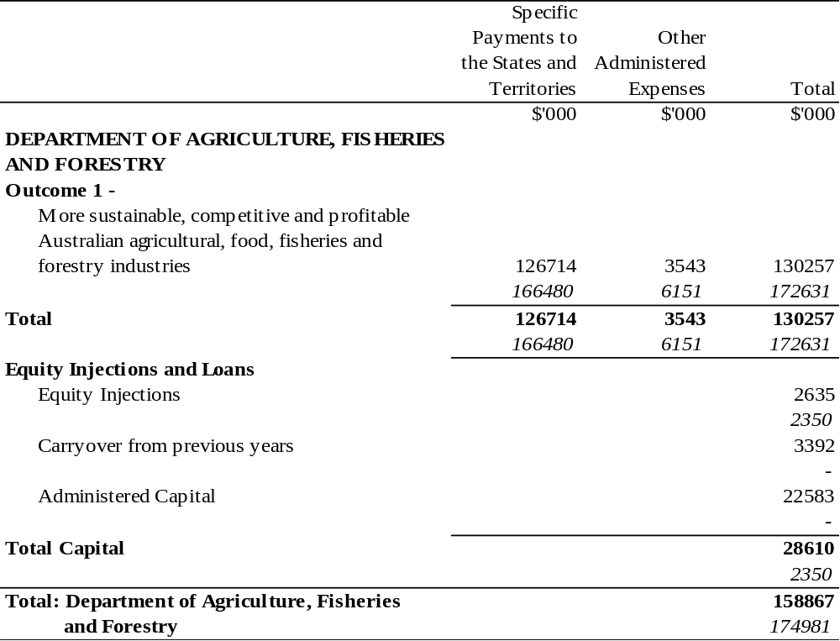

ATTORNEY-GENERAL’S PORTFOLIO

Appropriation (light figures) – 1999-2000
Estimated Expenses (italic figures) – 1998-1999
 |  |  | Specific
 |  |  | Payments to | Other
 |  |  | the States and | Administered
 |  |  | Territories | Expenses | Total
 |  |  | $'000 | $'000 | $'000
ATTORNEY-GENERAL’S DEPARTMENT
Outcome 1 -
 | An equitable and accessible system of
 | federal law and justice |  | 77587 | 58945 | 136532
 |  |  | 64088 | 57829 | 121917
Outcome 2 -
 | Coordinated security, crime prevention and
 | law enforcement arrangements |  | - | 3500 | 3500
 |  |  | - | 4790 | 4790
Total |  |  | 77587 | 62445 | 140032
 |  |  | 64088 | 62619 | 126707
Equity Injections and Loans
 | Carry over from previous years |  |  |  | 8300
 |  |  |  |  | 17964
 | Administered Capital |  |  |  | 56,834
 |  |  |  |  | 9202
Total Capital |  |  |  |  | 65042
 |  |  |  |  | 27166
Total: Attorney-General’s Department |  |  |  |  | 205074
 |  |  |  |  | 153873
Note 1: The ‘Totals’ in the table have not been adjusted to reflect the amendments made by the FMA Act Determination 2008/01- Section 32 (Transfer of Functions from the Department of Infrastructure, Transport, Regional Development and Local Government to the Attorney-General’s Department).
Note 2: Financial Management and Accountability Act 1997 Determination 2010/37 – Section 32 (Transfer of Functions from AGD to DORA) amended the amount opposite “Administered Capital”, under the heading “Total”, to transfer an amount to the Administered Assets and Liabilities item for the Department of Regional Australia, Regional Development and Local Government.

ATTORNEY-GENERAL’S PORTFOLIO

Appropriation (light figures) – 1999-2000
Estimated Expenses (italic figures) – 1998-1999
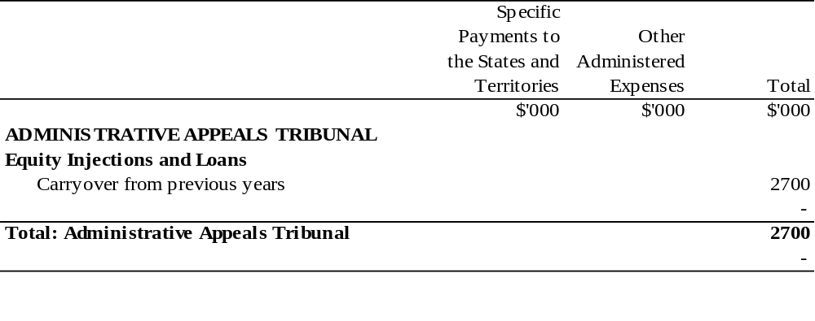
ATTORNEY-GENERAL’S PORTFOLIO
Appropriation (light figures) – 1999-2000
Estimated Expenses (italic figures) – 1998-1999
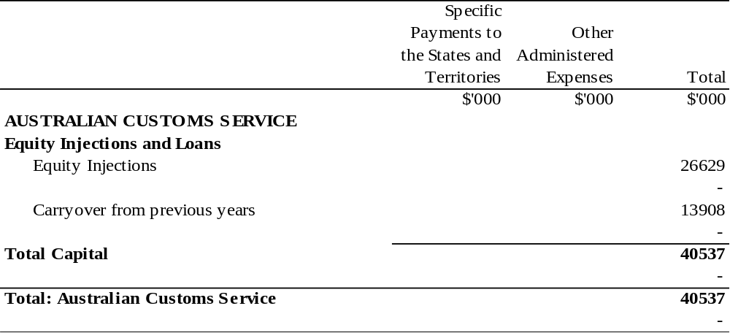

ATTORNEY-GENERAL’S PORTFOLIO

Appropriation (light figures) – 1999-2000
Estimated Expenses (italic figures) – 1998-1999
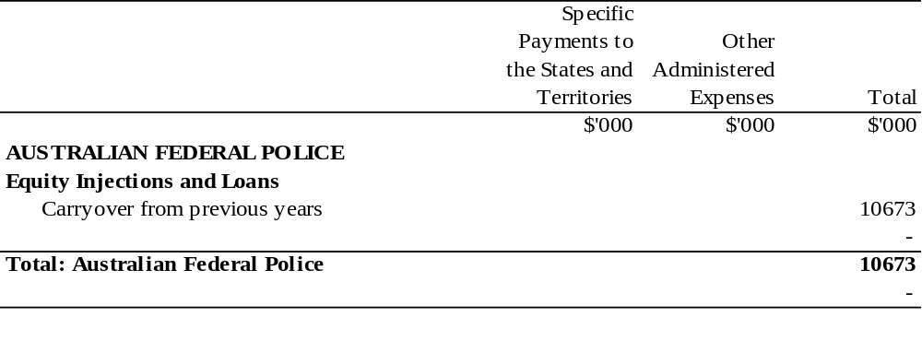

ATTORNEY-GENERAL’S PORTFOLIO

Appropriation (light figures) – 1999-2000
Estimated Expenses (italic figures) – 1998-1999
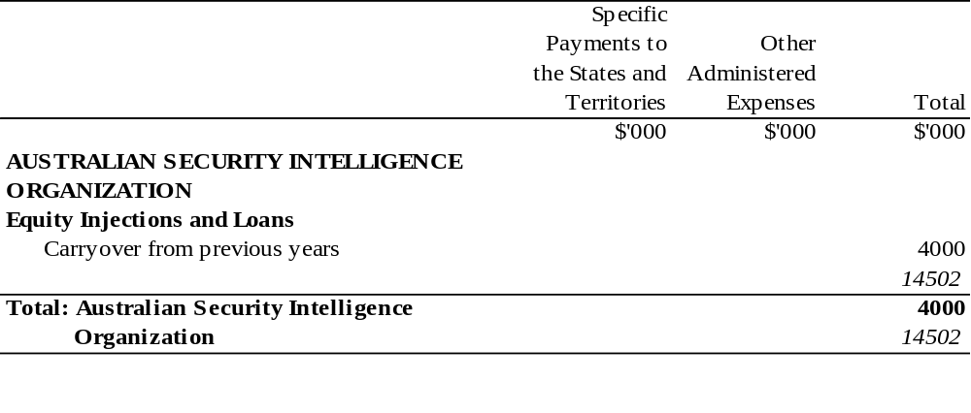

ATTORNEY-GENERAL’S PORTFOLIO

Appropriation (light figures) – 1999-2000
Estimated Expenses (italic figures) – 1998-1999
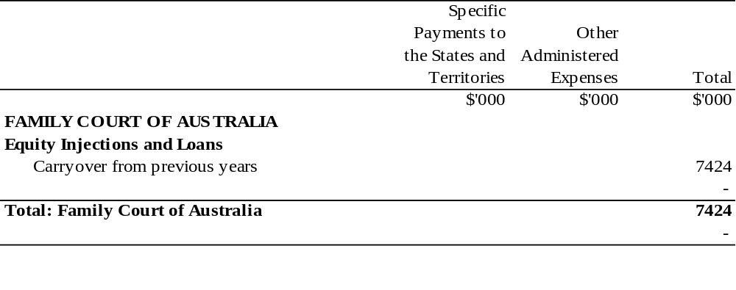

ATTORNEY-GENERAL’S PORTFOLIO

Appropriation (light figures) – 1999-2000
Estimated Expenses (italic figures) – 1998-1999
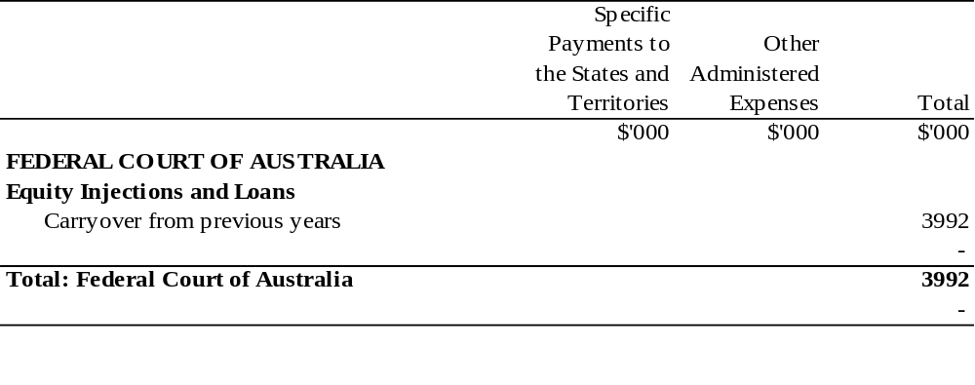

ATTORNEY-GENERAL’S PORTFOLIO

Appropriation (light figures) – 1999-2000
Estimated Expenses (italic figures) – 1998-1999
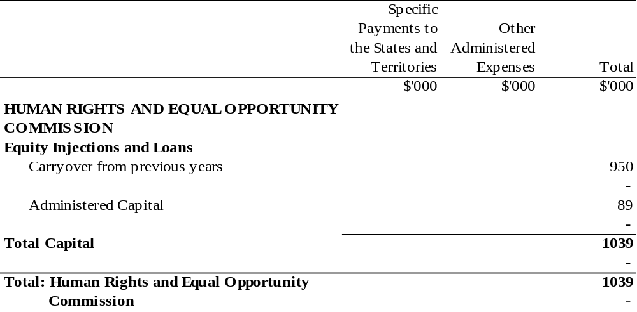

ATTORNEY-GENERAL’S PORTFOLIO

Appropriation (light figures) – 1999-2000
Estimated Expenses (italic figures) – 1998-1999
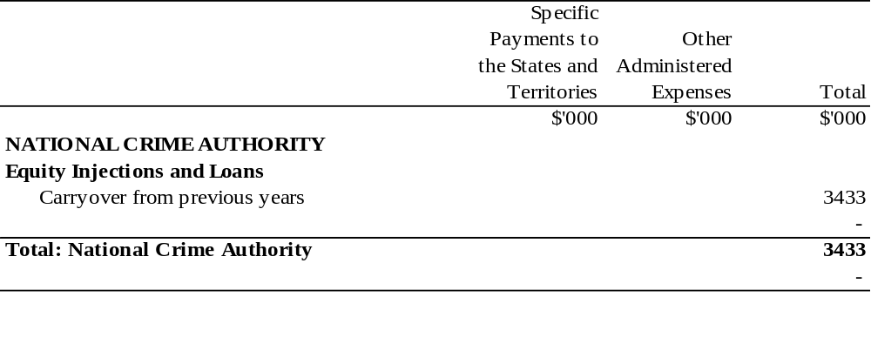
ATTORNEY-GENERAL’S PORTFOLIO
Appropriation (light figures) – 1999-2000
Estimated Expenses (italic figures) – 1998-1999
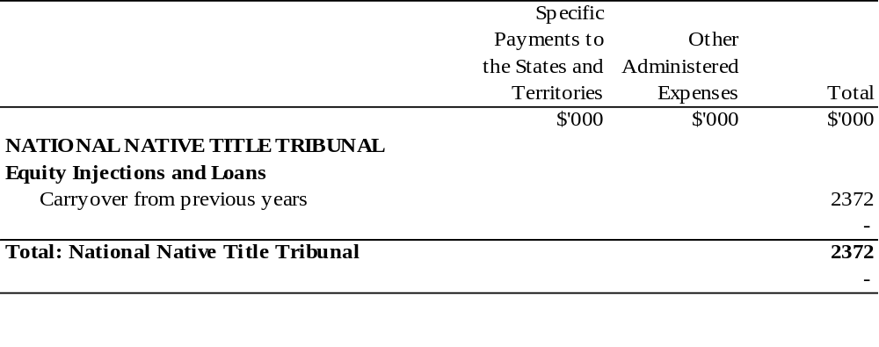

ATTORNEY-GENERAL’S PORTFOLIO

Appropriation (light figures) – 1999-2000
Estimated Expenses (italic figures) – 1998-1999
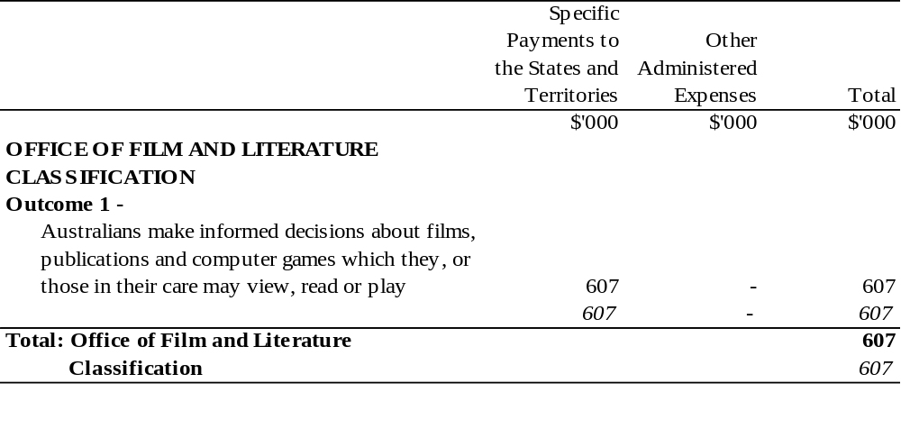
ATTORNEY-GENERAL’S PORTFOLIO
Appropriation (light figures) – 1999-2000
Estimated Expenses (italic figures) – 1998-1999
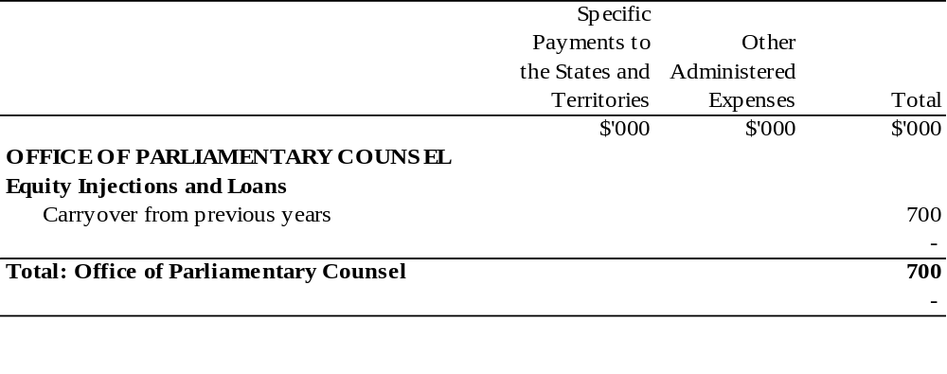

ATTORNEY-GENERAL’S PORTFOLIO

Appropriation (light figures) – 1999-2000
Estimated Expenses (italic figures) – 1998-1999
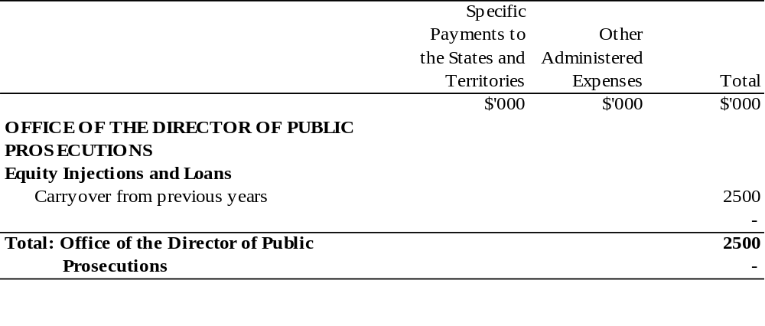

COMMUNICATIONS, INFORMATION TECHNOLOGY AND THE ARTS PORTFOLIO
Appropriation (light figures) – 1999-2000
Estimated Expenses (italic figures) – 1998-1999
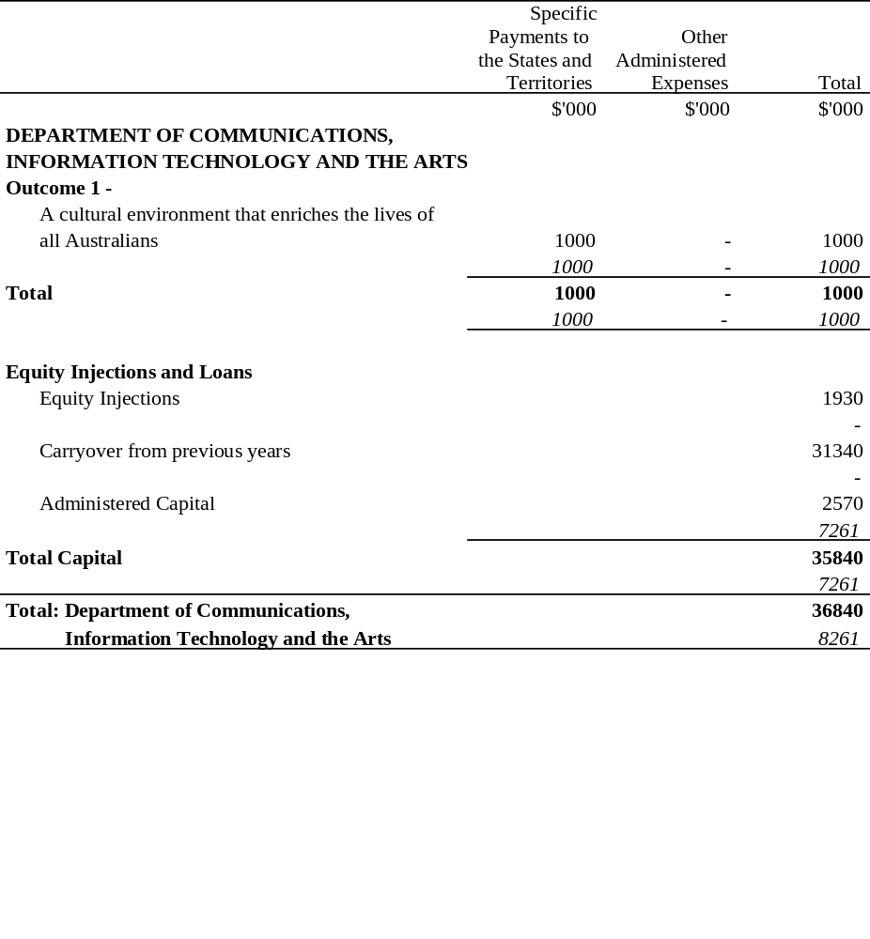
COMMUNICATIONS, INFORMATION TECHNOLOGY AND THE ARTS PORTFOLIO
Appropriation (light figures) – 1999-2000
Estimated Expenses (italic figures) – 1998-1999
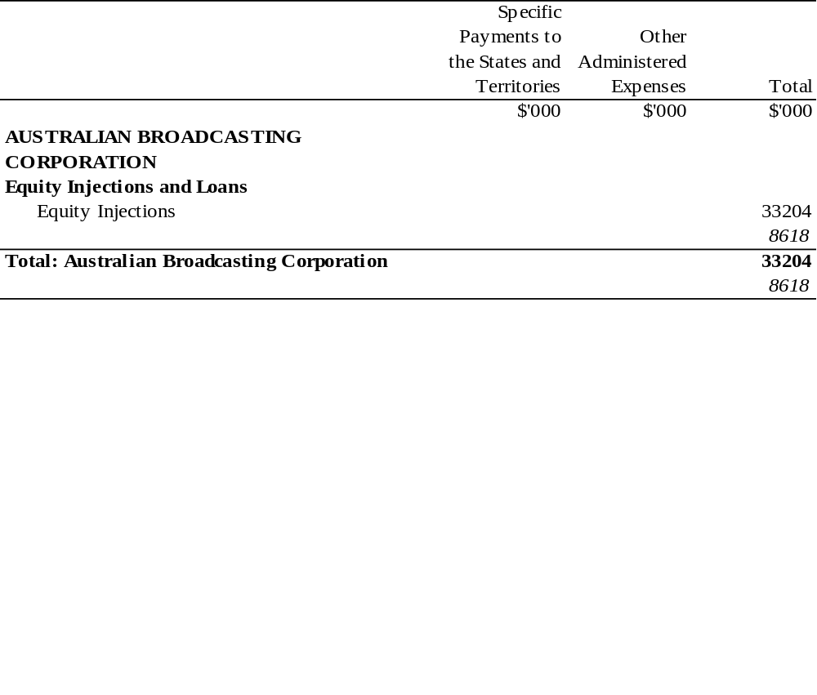
COMMUNICATIONS, INFORMATION TECHNOLOGY AND THE ARTS PORTFOLIO
Appropriation (light figures) – 1999-2000
Estimated Expenses (italic figures) – 1998-1999
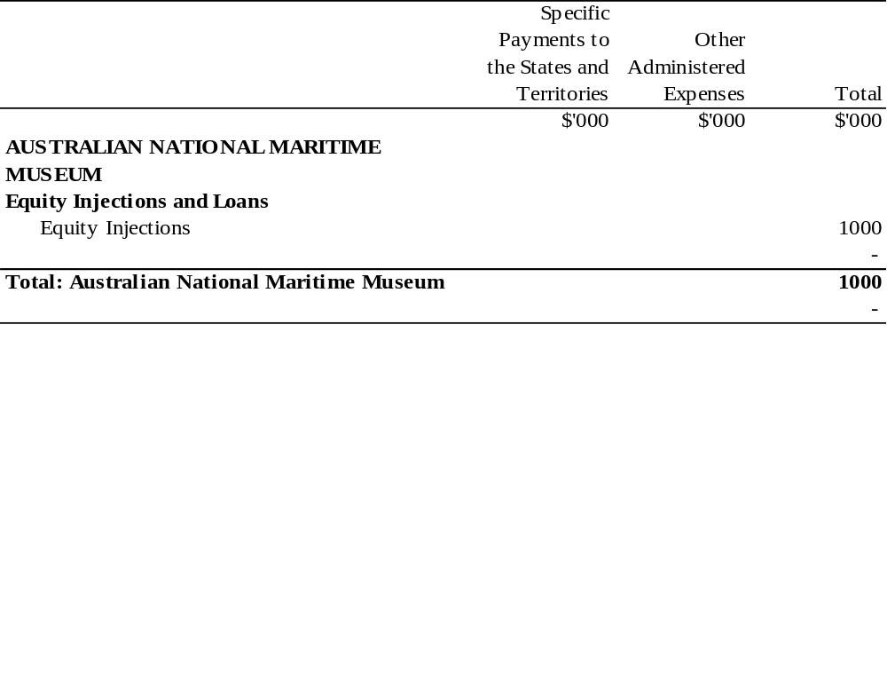
COMMUNICATIONS, INFORMATION TECHNOLOGY AND THE ARTS PORTFOLIO
Appropriation (light figures) – 1999-2000
Estimated Expenses (italic figures) – 1998-1999
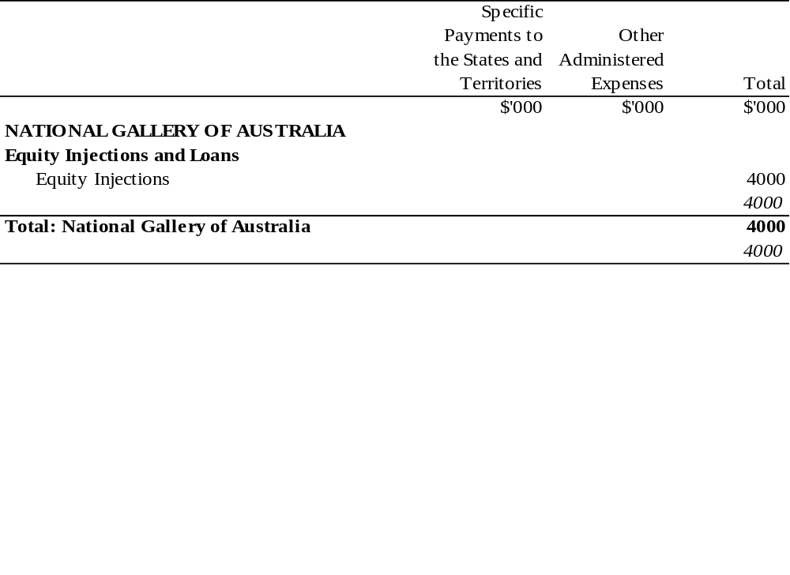
COMMUNICATIONS, INFORMATION TECHNOLOGY AND THE ARTS PORTFOLIO
Appropriation (light figures) – 1999-2000
Estimated Expenses (italic figures) – 1998-1999
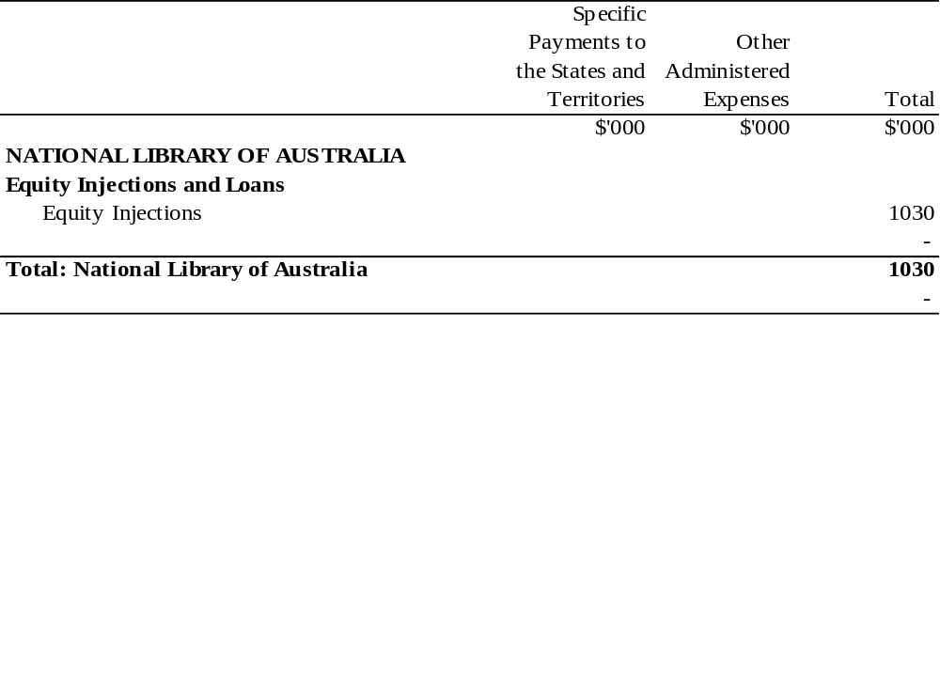

COMMUNICATIONS, INFORMATION TECHNOLOGY AND THE ARTS PORTFOLIO
Appropriation (light figures) – 1999-2000
Estimated Expenses (italic figures) – 1998-1999
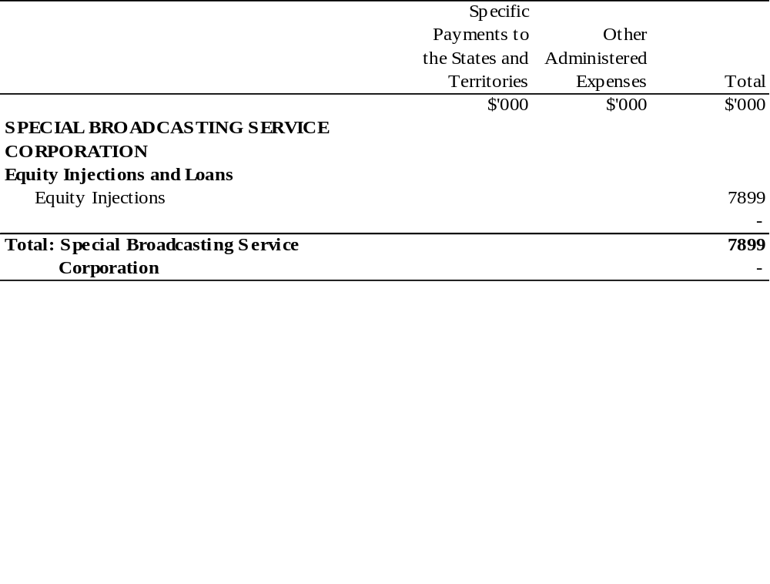

DEFENCE PORTFOLIO

Appropriation (light figures) – 1999-2000
Estimated Expenses (italic figures) – 1998-1999
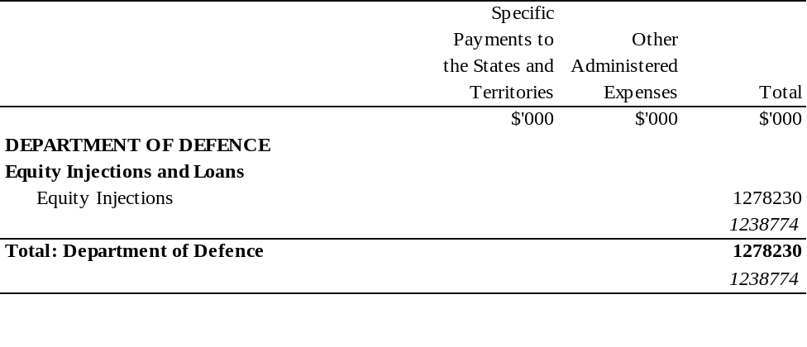

VETERANS’ AFFAIRS PORTFOLIO

Appropriation (light figures) – 1999-2000
Estimated Expenses (italic figures) – 1998-1999
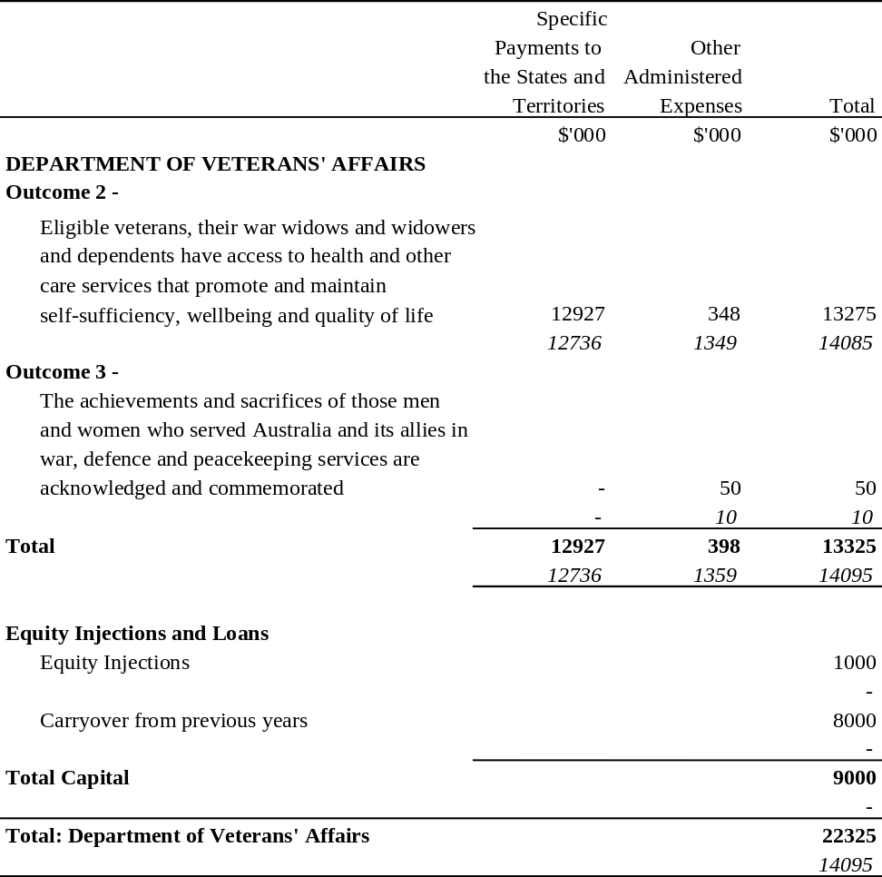

EDUCATION, TRAINING AND YOUTH AFFAIRS PORTFOLIO

Appropriation (light figures) – 1999-2000
Estimated Expenses (italic figures) – 1998-1999
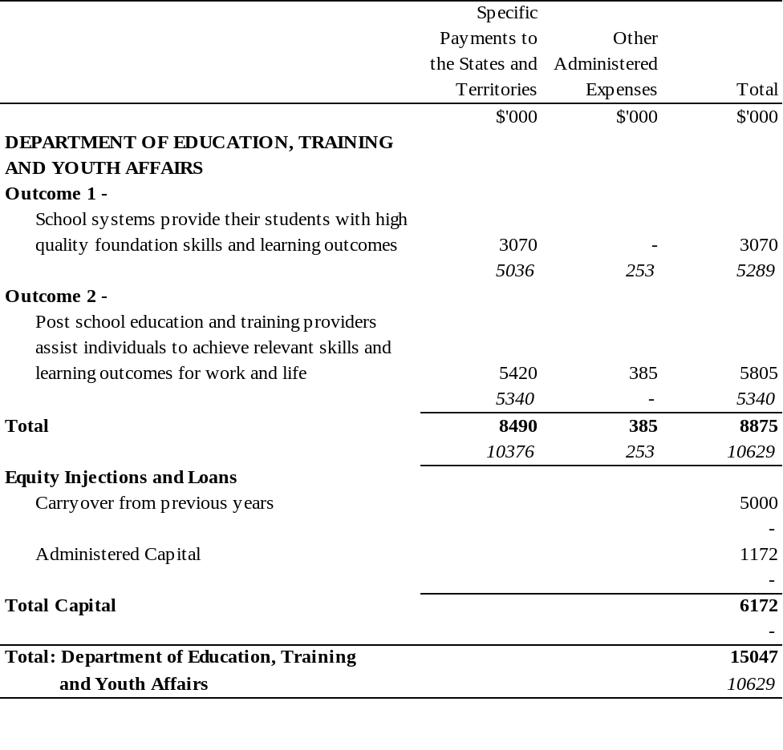
EMPLOYMENT, WORKPLACE RELATIONS AND SMALL BUSINESS PORTFOLIO
Appropriation (light figures) – 1999-2000
Estimated Expenses (italic figures) – 1998-1999
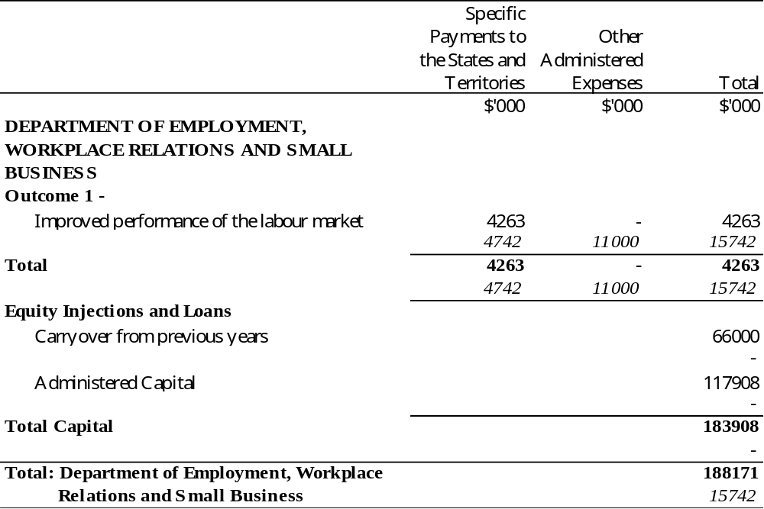
EMPLOYMENT, WORKPLACE RELATIONS AND SMALL BUSINESS PORTFOLIO
Appropriation (light figures) – 1999-2000
Estimated Expenses (italic figures) – 1998-1999
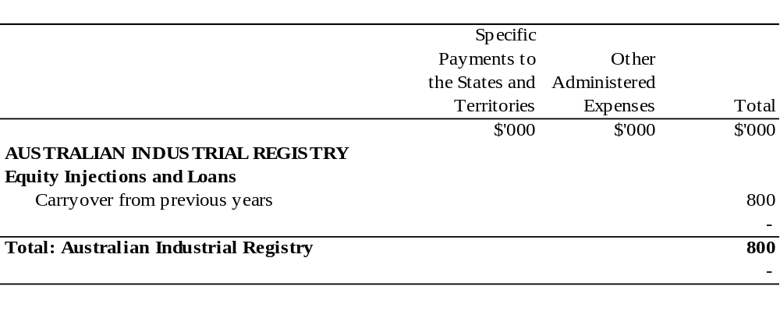
ENVIRONMENT AND HERITAGE PORTFOLIO

Appropriation (light figures) – 1999-2000
Estimated Expenses (italic figures) – 1998-1999
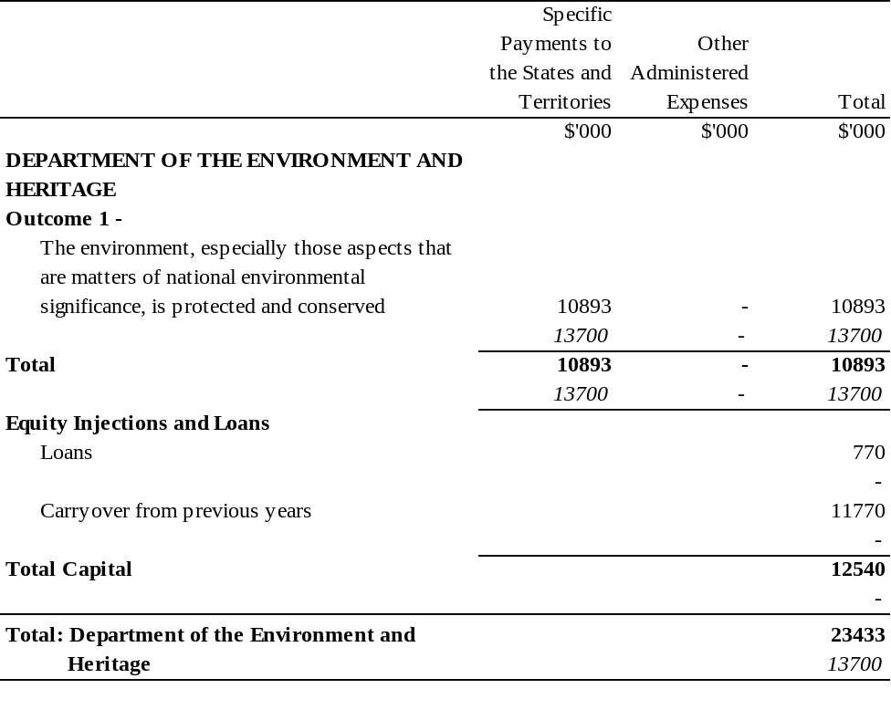

ENVIRONMENT AND HERITAGE PORTFOLIO

Appropriation (light figures) – 1999-2000
Estimated Expenses (italic figures) – 1998-1999
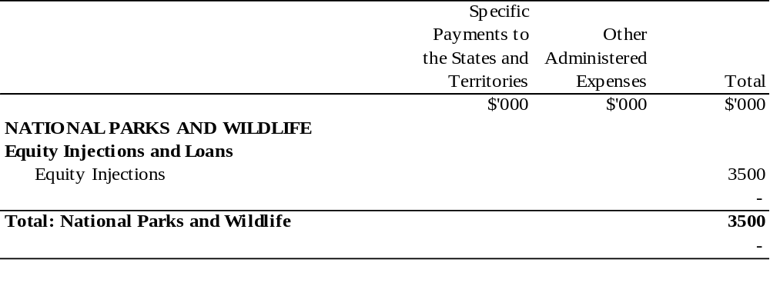

FAMILY AND COMMUNITY SERVICES PORTFOLIO

Appropriation (light figures) – 1999-2000
Estimated Expenses (italic figures) – 1998-1999
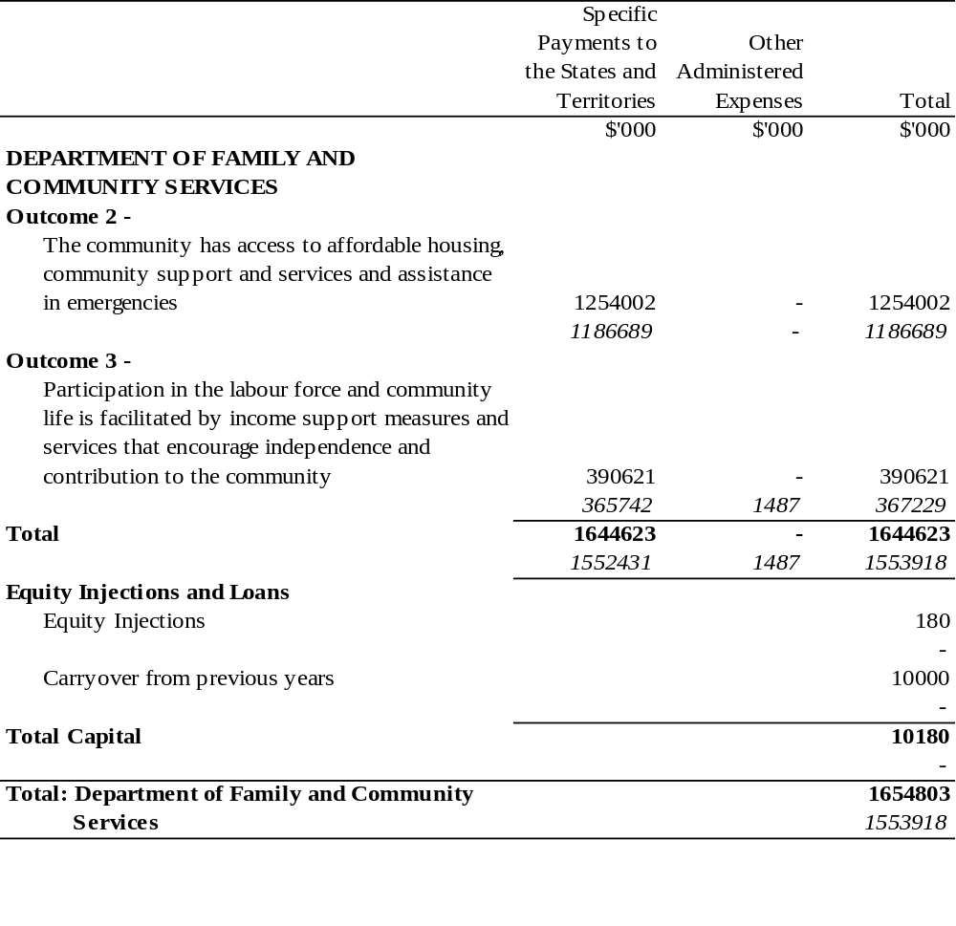

FAMILY AND COMMUNITY SERVICES PORTFOLIO

Appropriation (light figures) – 1999-2000
Estimated Expenses (italic figures) – 1998-1999
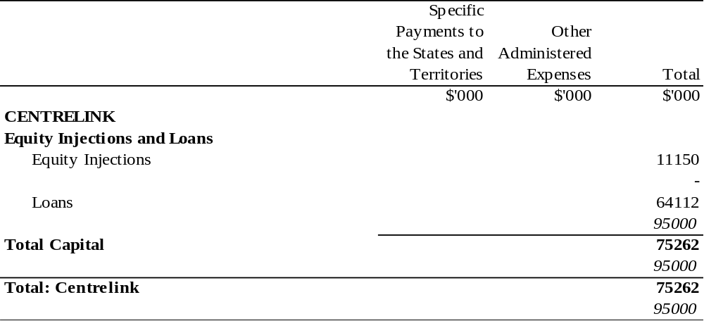

FINANCE AND ADMINISTRATION PORTFOLIO

Appropriation (light figures) – 1999-2000
Estimated Expenses (italic figures) – 1998-1999
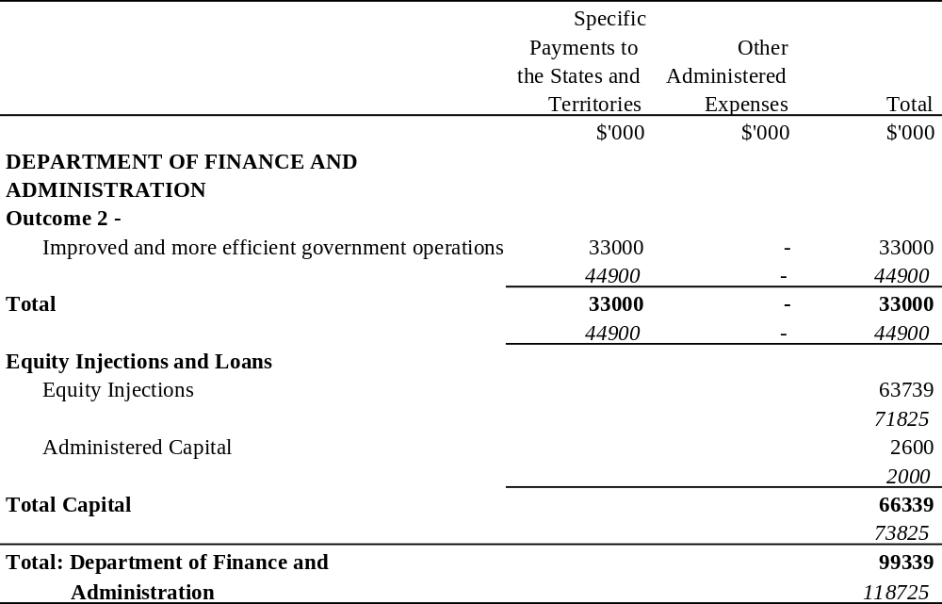

FINANCE AND ADMINISTRATION PORTFOLIO

Appropriation (light figures) – 1999-2000
Estimated Expenses (italic figures) – 1998-1999
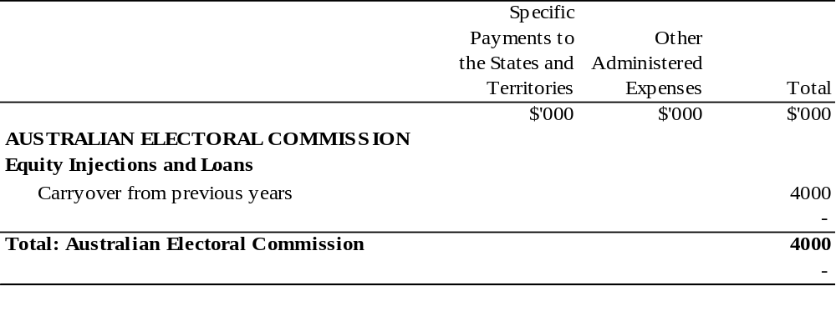

FINANCE AND ADMINISTRATION PORTFOLIO

Appropriation (light figures) – 1999-2000
Estimated Expenses (italic figures) – 1998-1999
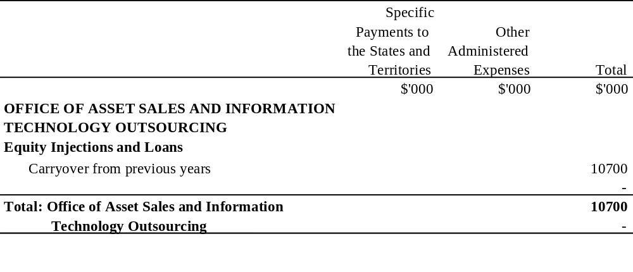

FOREIGN AFFAIRS AND TRADE PORTFOLIO

Appropriation (light figures) – 1999-2000
Estimated Expenses (italic figures) – 1998-1999
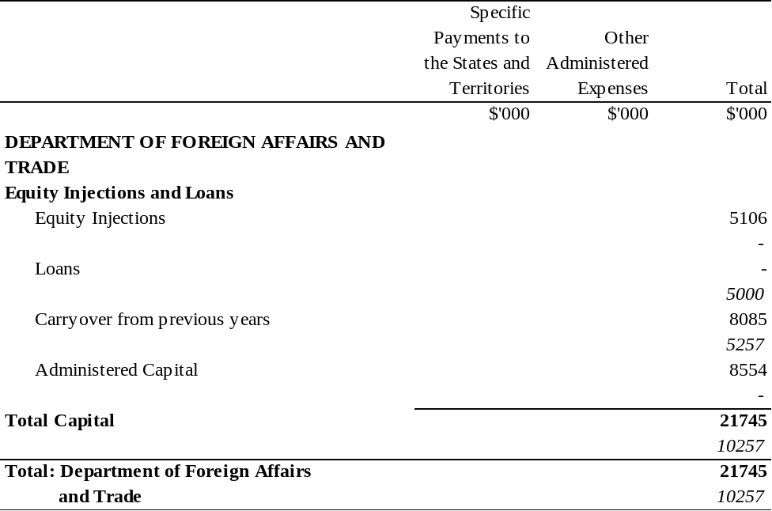

FOREIGN AFFAIRS AND TRADE PORTFOLIO

Appropriation (light figures) – 1999-2000
Estimated Expenses (italic figures) – 1998-1999
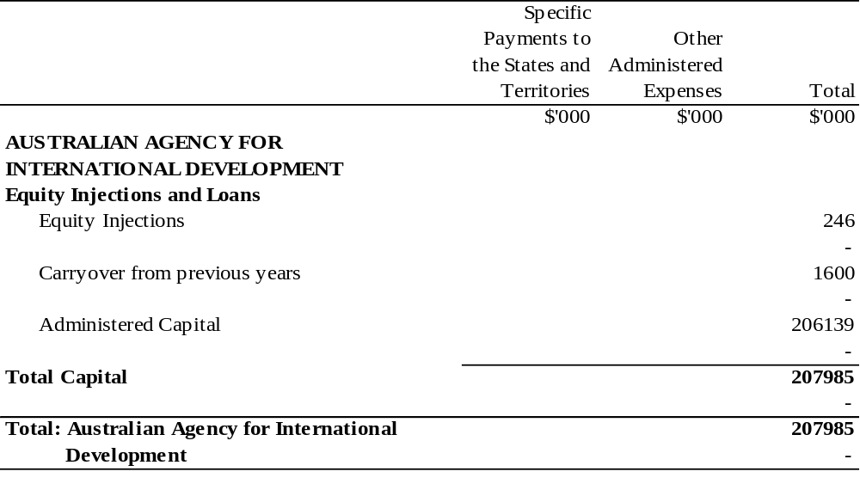

FOREIGN AFFAIRS AND TRADE PORTFOLIO

Appropriation (light figures) – 1999-2000
Estimated Expenses (italic figures) – 1998-1999
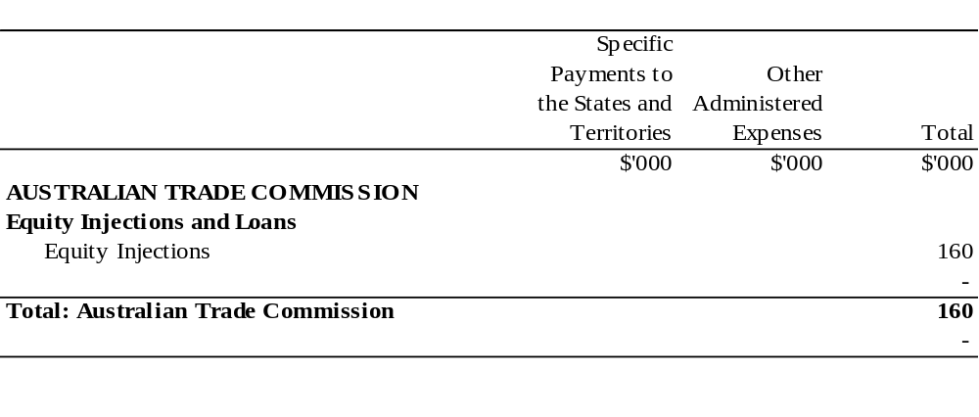

HEALTH AND AGED CARE PORTFOLIO

Appropriation (light figures) – 1999-2000
Estimated Expenses (italic figures) – 1998-1999
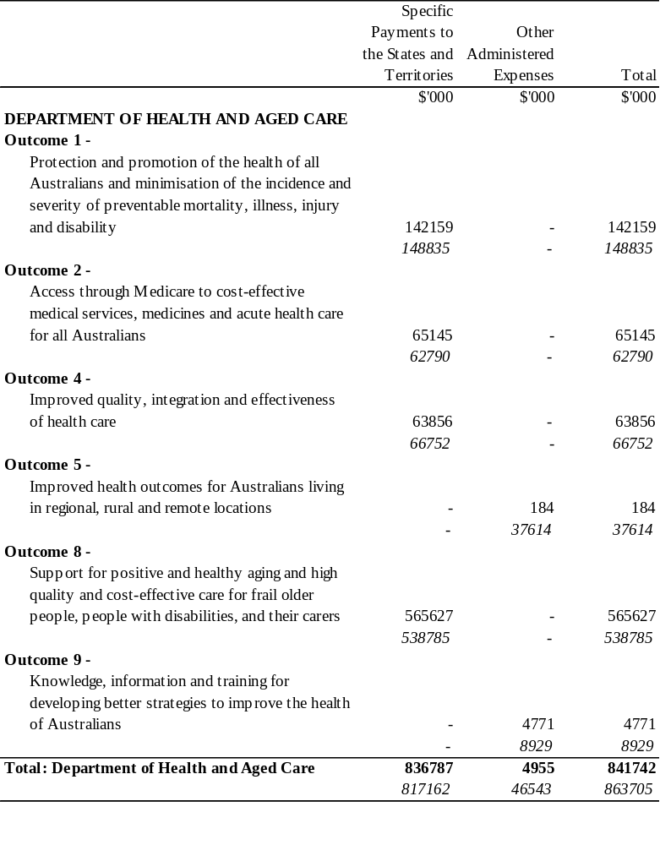
HEALTH AND AGED CARE PORTFOLIO

Appropriation (light figures) – 1999-2000
Estimated Expenses (italic figures) – 1998-1999
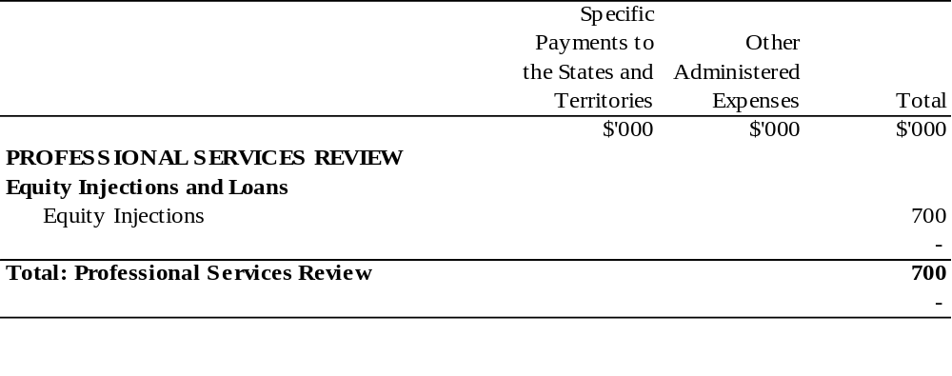

IMMIGRATION AND MULTICULTURAL AFFAIRS PORTFOLIO

Appropriation (light figures) – 1999-2000
Estimated Expenses (italic figures) – 1998-1999
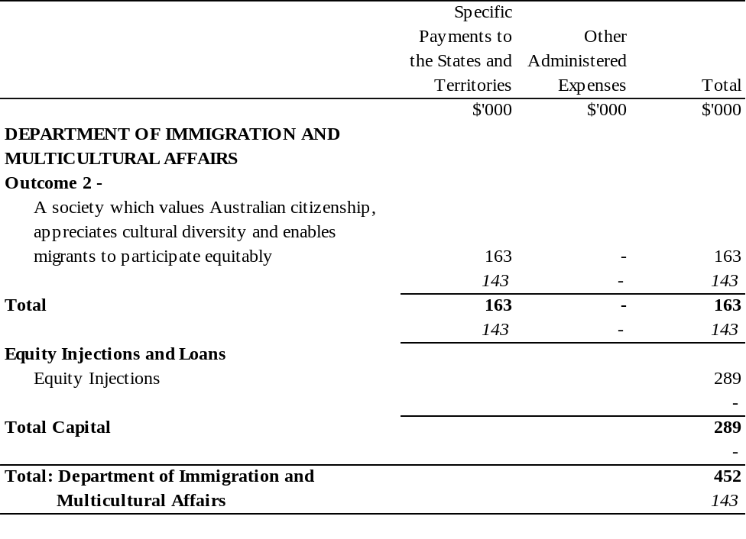

INDUSTRY, SCIENCE AND RESOURCES PORTFOLIO

Appropriation (light figures) – 1999-2000
Estimated Expenses (italic figures) – 1998-1999
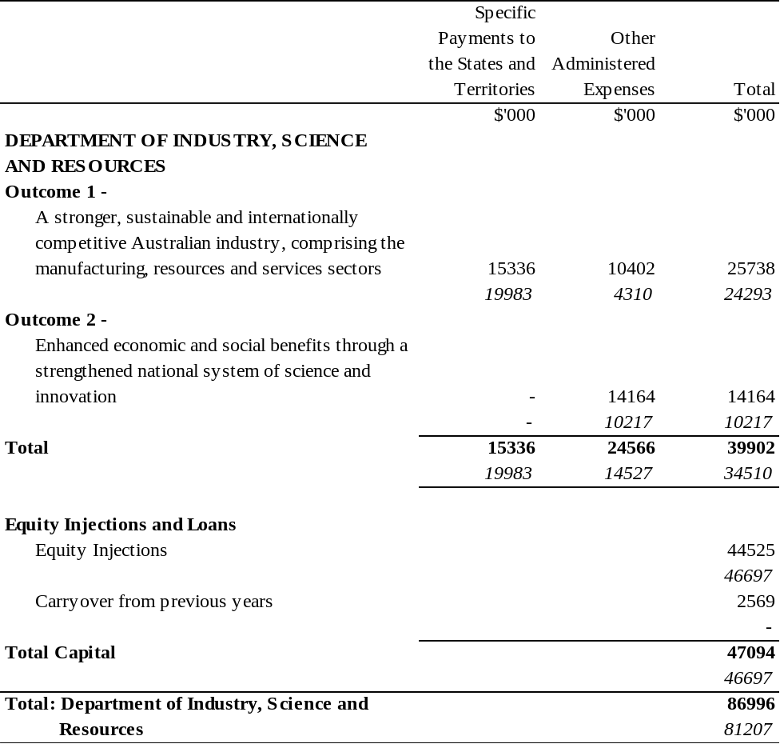

PRIME MINISTER AND CABINET PORTFOLIO

Appropriation (light figures) – 1999-2000
Estimated Expenses (italic figures) – 1998-1999
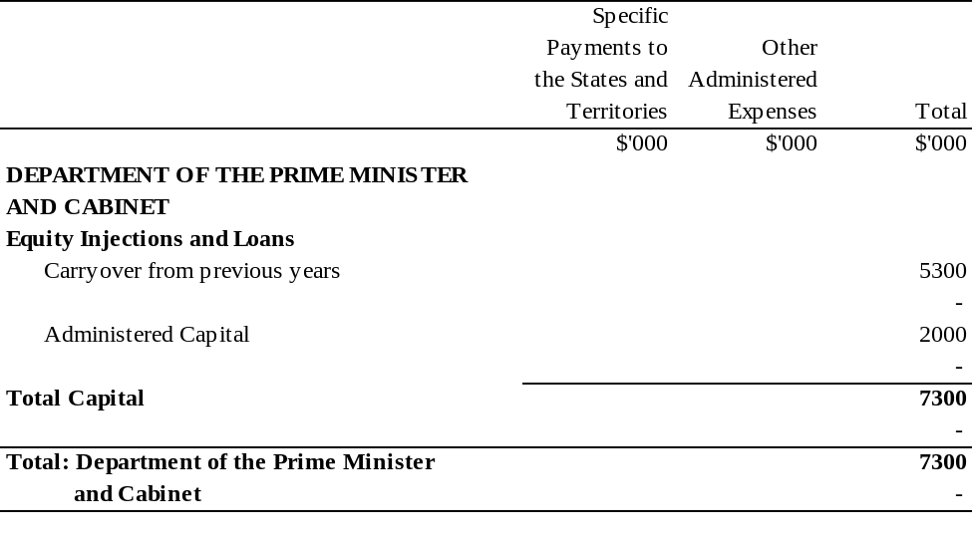

PRIME MINISTER AND CABINET PORTFOLIO

Appropriation (light figures) – 1999-2000
Estimated Expenses (italic figures) – 1998-1999
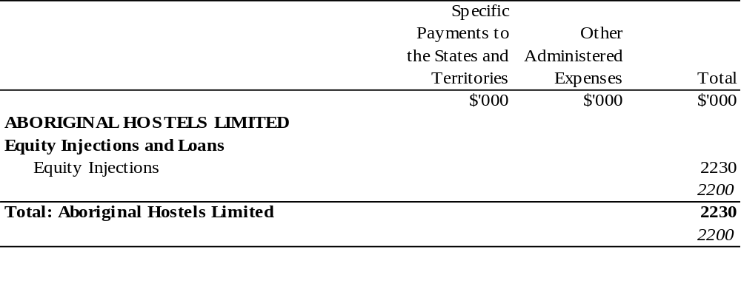

PRIME MINISTER AND CABINET PORTFOLIO

Appropriation (light figures) – 1999-2000
Estimated Expenses (italic figures) – 1998-1999
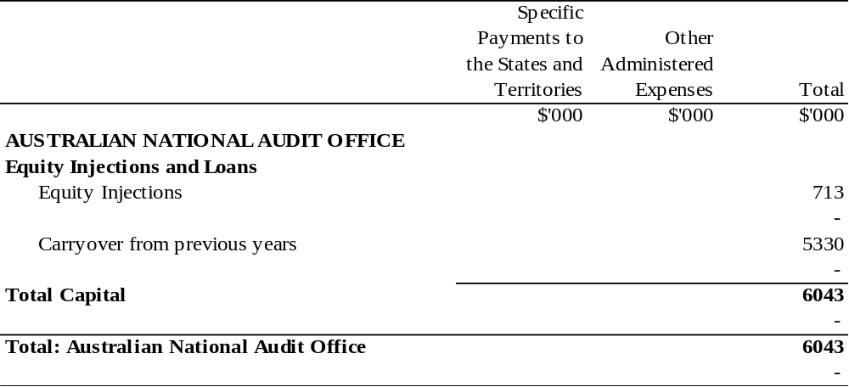

PRIME MINISTER AND CABINET PORTFOLIO

Appropriation (light figures) – 1999-2000
Estimated Expenses (italic figures) – 1998-1999
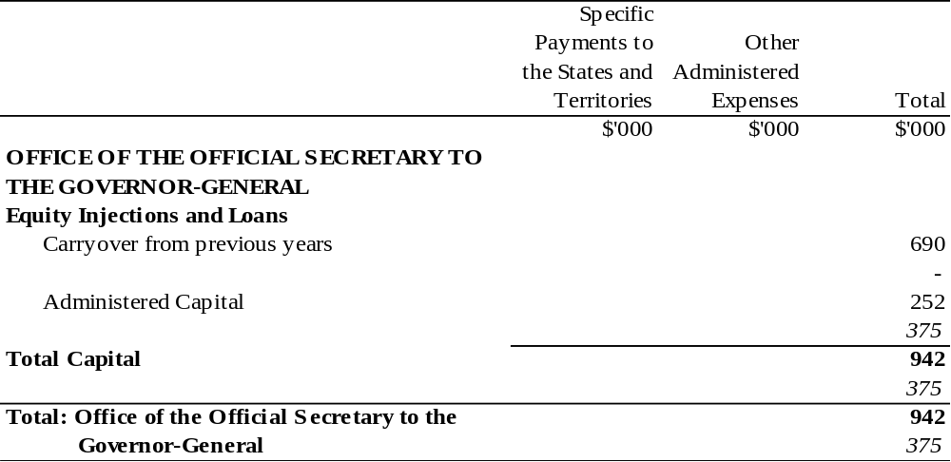

PRIME MINISTER AND CABINET PORTFOLIO

Appropriation (light figures) – 1999-2000
Estimated Expenses (italic figures) – 1998-1999
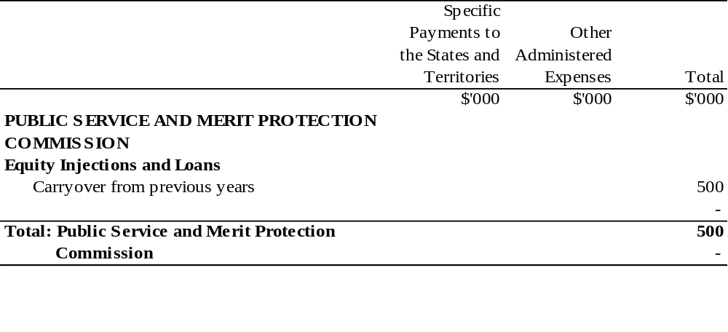

TRANSPORT AND REGIONAL SERVICES PORTFOLIO

Appropriation (light figures) – 1999-2000
Estimated Expenses (italic figures) – 1998-1999
 |  |  |  | Specific
 |  |  |  | Payments to | Other
 |  |  |  | the States and | Administered
 |  |  |  | Territories | Expenses | Total
 |  |  |  | $'000 | $'000 | $'000
DEPARTMENT OF TRANSPORT AND REGIONAL SERVICES
Outcome 1 -
 | Linking Australia through transport and
 | regional services |  |  | 29555 | 145937 | 175492
 |  |  |  | 28137 | 147661 | 175798
Total |  |  |  | 29555 | 145937 | 175492
 |  |  |  | 28137 | 147661 | 175798
Equity Injections and Loans
 | Equity Injections |  |  |  |  | 5974
 |  |  |  |  |  | -
 | Carry over from previous years |  |  |  |  | 6000
 |  |  |  |  |  | -
 | Administered Capital |  |  |  |  | 1,753.13932
 |  |  |  |  |  | 690967
Total Capital |  |  |  |  |  | 14074
 |  |  |  |  |  | 690967
Total: Department of Transport and |  |  |  |  |  | 189566
 |  | Regional Services |  |  |  | 866765
Note The ‘Totals’ in the table have not been adjusted to reflect the amendments made by the FMA Act Determination 2008/01 — Section 32 (Transfer of Functions from the Department of Infrastructure, Transport, Regional Development and Local Government to the Attorney-General’s Department).

TRANSPORT AND REGIONAL SERVICES PORTFOLIO

Appropriation (light figures) – 1999-2000
Estimated Expenses (italic figures) – 1998-1999
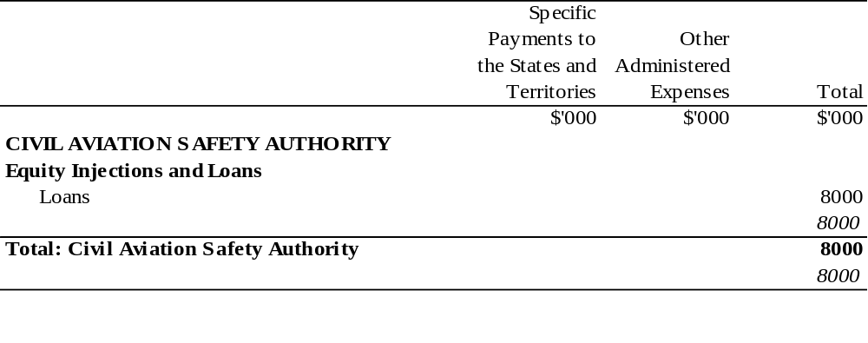

TRANSPORT AND REGIONAL SERVICES PORTFOLIO

Appropriation (light figures) – 1999-2000
Estimated Expenses (italic figures) – 1998-1999
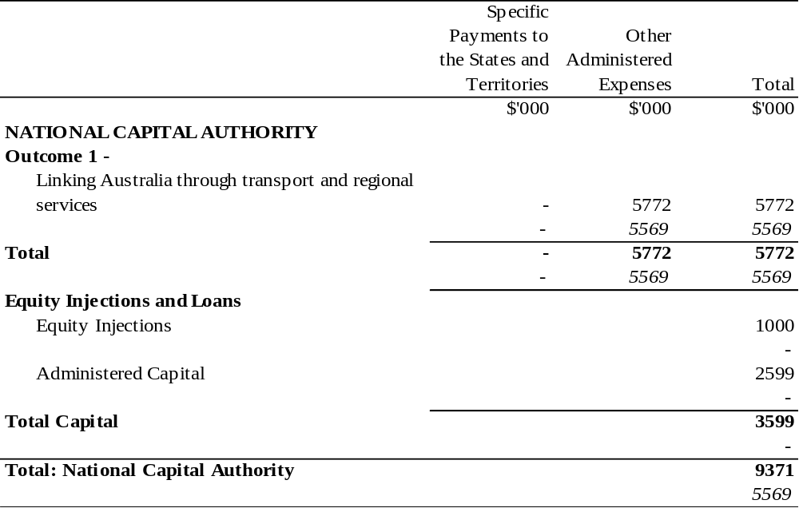

TREASURY PORTFOLIO

Appropriation (light figures) – 1999-2000
Estimated Expenses (italic figures) – 1998-1999
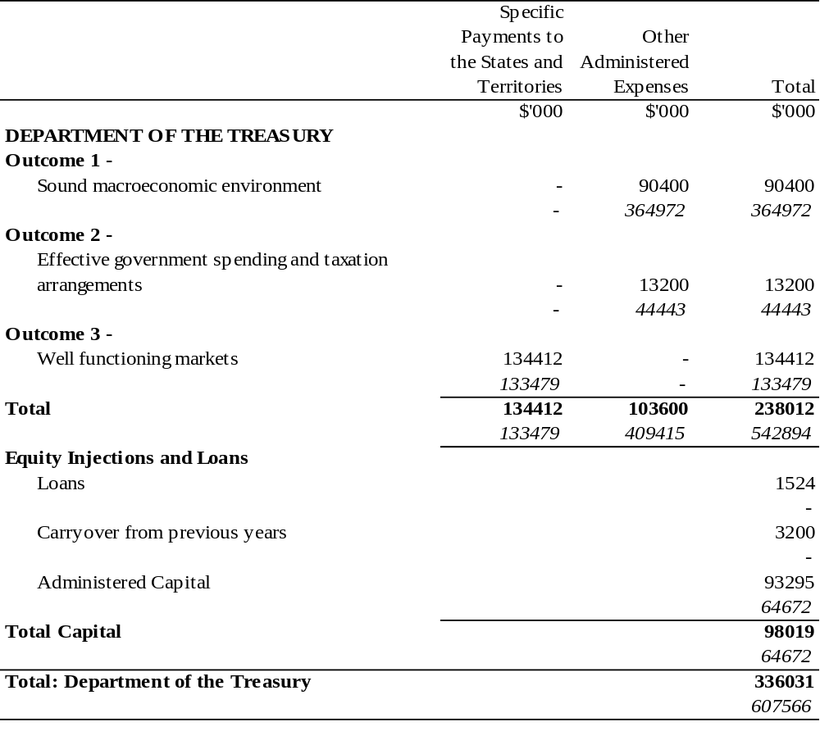

TREASURY PORTFOLIO

Appropriation (light figures) – 1999-2000
Estimated Expenses (italic figures) – 1998-1999
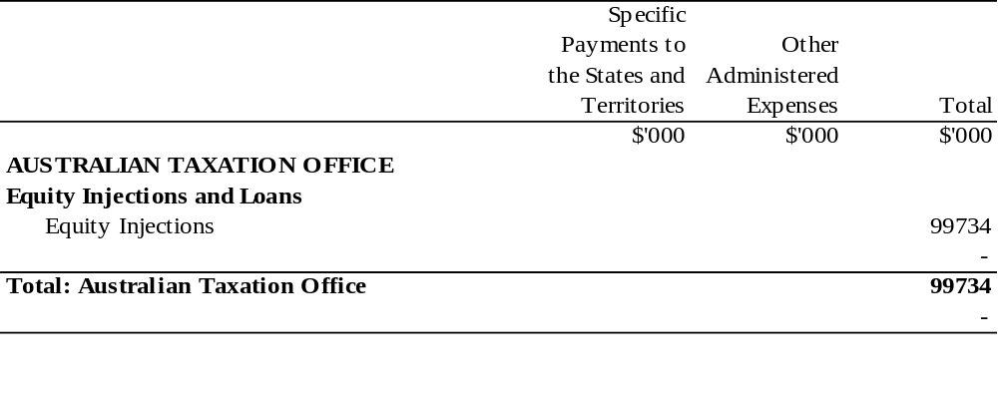
Notes to the Appropriation Act (No. 2) 1999-2000
Note 1
The Appropriation Act (No. 2) 1999-2000 as shown in this compilation comprises Act No. 47, 1999 amended as indicated in the Tables below.
Table of Acts/Instruments
Title | Year  and number | Date  of Assent or Date of FRLI registration | Date of commencement | Application, saving or transitional provisions
Appropriation Act (No. 2) 1999-2000 | 47, 1999 | 30 June 1999 | 30 June 1999
FMA Act Determination 2008/01 — Section 32 (Transfer of Functions from the Department of Infrastructure, Transport, Regional Development and Local Government to the Attorney-General’s Department) | 2008/01 | 7 Feb 2008 (see F2008L00296) | 24 Jan 2008 | —
Financial Management and Accountability Act 1997 Determination 2010/37 — Section 32 (Transfer of Functions from AGD to DORA) | 2010/37 | 8 Dec 2010 (see F2010L03203) | C. 3 and Schedule 1: 2 Dec 2010 | —

Table of Amendments
ad. = added or inserted am. = amended rep. = repealed rs. = repealed and substituted
Provision affected | How affected
Schedule 2
Schedule 2 | am. Nos. 2008/01 and 2010/37

